The data that is returned is dependent on what kind of control the response data from the Ajax
service is associated with. For here, let us assume it is a Single Selection list. A Single Selection
list is defined by a list of NameValuePair data structures. The NameValuePair is a IBPM
predefined data structure that contains two fields. One called name and the other called value.
When a list of these structures is associated with a Single Selection list control, each element in the list data contributes one row to the visual list control. The name field is used as the visual in the row.
返回的数据取决于与Ajax服务响应数据相关的控制类型。这里我们假设一个下拉菜单，用一系列NameValuePair类型的集合来定义这个下拉菜单。NameValuePair 是一个IBPM预定义的数据结构，它包含两个属性。一个叫做name，另一个叫value。当一系列这个种类型的数据与一个下拉菜单控件发生关联时，数据集合中的每一个元素对应下拉菜单的每一行，这个name属性用作对应行的显示值。

Let us examine this by example. Imagine our business is split into two regions. The East and the West. When we wish to ship product, we ship from the East region or the West region. In each region, we have the choice of possible shipping warehouses from which to ship. If we want to
present a Coach to select a warehouse, we might want to be smart and allow the user to first select a region and once the region is selected, then select a warehouse. The allowable warehouse values
should be displayed based on the region selected. This is illustrated in the following diagrams

我们用例子来解释，假设我们的业务分为两个地区，东部和西部。当我们想发货时，从东部，或者西部发货运。我们可以选择合适的发货点发货。如果我们想提供一个Coach来选择发货点，可能我们想做的智能一点，允许用户先选择一个地区，一旦地区被选定，然后选择一个发货点。这样根据选定的地区会显示不同的发货点。如下图所示：
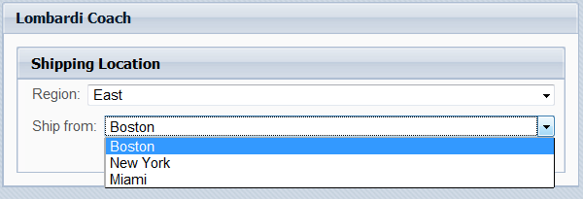
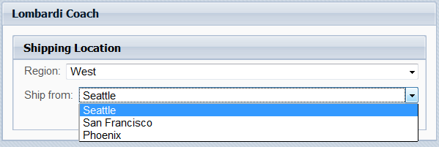

To achieve this, we might build a Coach that looks as follows:
为达到这样一个母的，我们需要建如下一个Coach：
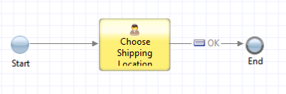
With the body of the Coach looking like:
Coach的具体实现如下：
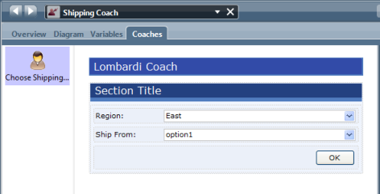
<Needs updated for IBPM>
The Shipping Location section contains two Single Select controls. The first which has the label
"Region:" contains static choices:
发货地址部分包含两个下拉菜单控件。标签名叫Region的控件包含两个静态的选项如下：
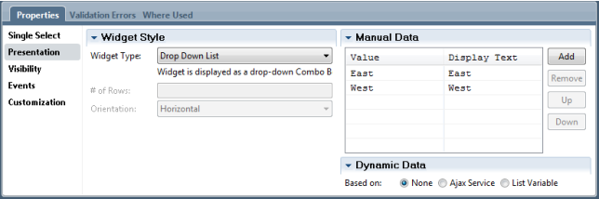
The second control is the more interesting one. Looking at its definition we see that it invokes an
Ajax defined service.
第二个控件比较有意思。从它的定义，我们可以看出它调用了一个Ajax服务。
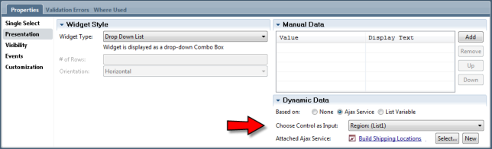
Notice three things:
1.It has the radio button selected for an Ajax service
2.It names the other control as the trigger that will invoke the service
3.It names an Ajax service that will be called to return the data that will be used to populate this
Control.
注意一下三点：
- 选中Ajax service按钮
- 名叫other的控件会作为触发器调用该服务
- 被引用的Ajax service将会被调用来返回数据来填充该下拉菜单

Now let us look at the definition of the Ajax service. As a high level diagram, it contains only one
Server Script activity:

现在我们来看一下Ajax服务的定义。作为一个上层的图表，它只包含了一个Server Script脚本：
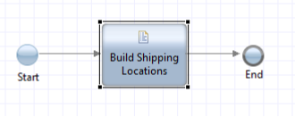
该Service的变量定义如下：
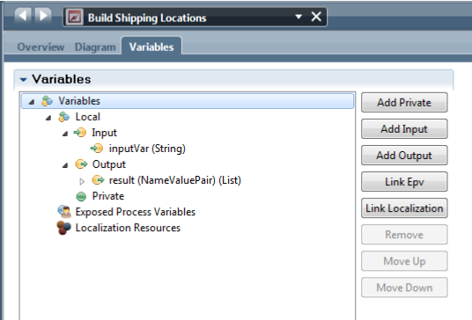
Note that there is an input variable that must be called inputVar. The output variable has no
restriction on its name but result is a suggested choice. The data type of the output variable is a List of NameValuePair data types.
Finally, there is the JavaScript logic contained in the Server Script:

注意必须有一个输入变量叫inputVar。输出变量对命名没有限制，但有个推荐选项，就是输出变量的类型最好是NameValuePair 的集合。
最后，有一段JavaScript 逻辑包含在 Server Script:脚本里：
tw.local.result = new tw.object.listOf.NameValuePair();
if (tw.local.inputVar == "East")
{
tw.local.result[0] = new tw.object.NameValuePair();
tw.local.result[0].name = "Boston";
tw.local.result[0].value = "Boston";
tw.local.result[1] = new tw.object.NameValuePair();
tw.local.result[1].name = "New York";
tw.local.result[1].value = "New York";
tw.local.result[2] = new tw.object.NameValuePair();
tw.local.result[2].name = "Miami";
tw.local.result[2].value = "Miami";
}
if (tw.local.inputVar == "West")
{
tw.local.result[0] = new tw.object.NameValuePair();
tw.local.result[0].name = "Seattle";
tw.local.result[0].value = "Seattle";
tw.local.result[1] = new tw.object.NameValuePair();
tw.local.result[1].name = "San Francisco";
tw.local.result[1].value = "San Francisco";
tw.local.result[2] = new tw.object.NameValuePair();
tw.local.result[2].name = "Phoenix";
tw.local.result[2].value = "Phoenix";
}

This script won't be explained in detail other than to say that depending on the value of the input
data which is the value of the region selection control, one of two different lists of data are built and returned.

正是这段脚本被详细解释起作用，而不是说依赖于region选项作为的输入参数，两个不同数据的集合之一将会产生并且返回。
Not all components support Ajax service binding, the ones that do are:
•Text Input – The Ajax service should return an array of strings
•Text Output – The Ajax service should return an array of strings
•Combo Box (Single Select – Drop Down List) – The Ajax service should return an array of
NameValuePairs
•Table – The Ajax service should return …?

不是所有的组件都支持Ajax service的绑定，支持的组件如下：
•输入文本 –Ajax service应当返回字符串数组
•输出文本 –Ajax service应当返回字符串数组
•组合框（单选–下拉菜单）–Ajax service应当返回NameValuePairs
•表–Ajax service应当返回…?
In practice, the data that is returned from the Ajax service call may be dynamically sourced such as through a DB lookup.
实际操作中，Ajax service返回的数据可以动态地获取比如通过数据库查询。

See also:
•Error: Reference source not found
•Video - IBM BPM 7.5 - Calling an Ajax service from a Coach - 2011-06-27

Integration Service
The integration service allows a process to invoke an external entity such as a Web Service or a
piece of Java Code. It is the integration service which provides the one of the components for
interacting with logic outside of the BPMN environment including true SOA external service.

集成服务
Integration service允许一个过程调用一个外部的实体比如一个网络服务或者一段Java代码。
这种集成服务提供了一个组件用来集成BPMN以外的逻辑包含SOA外部服务。

